Module-10

Electric current
An electric current is the rate of flow of electric charge past a pointor region. An electric current is said to exist when there is a net flow of electric charge through a region. In electric circuits this charge is often carried by electrons moving through a wire. It can also be carried by ions in an electrolyte, or by both ions and electrons such as in an ionized gas (plasma).
The SI unit of electric current is the ampere, which is the flow of electric charge across a surface at the rate of one coulomb per second. The ampere (symbol: A) is an SI base unit Electric current is measured using a device called an ammeter.
Electric currents cause Joule heating, which creates light in incandescent light bulbs. They also create magnetic fields, which are used in motors, generators, inductors, and transformers.
The moving charged particles in an electric current are called charge carriers. In metals, one or more electrons from each atom are loosely bound to the atom, and can move freely about within the metal. These conduction electrons are the charge carriers in metal conductors.

Ohm's law
Ohm's law states that the current through a conductor between two points is directly proportional to the potential difference across the two points. Introducing the constant of proportionality, the resistance, one arrives at the usual mathematical equation that describes this relationship:
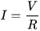
where I is the current through the conductor in units of amperes, V is the potential difference measured across the conductor in units of volts, and R is the resistance of the conductor in units of ohms. More specifically, Ohm's law states that the R in this relation is constant, independent of the current.
Application of Ohms law:
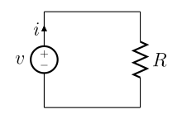
Fig.1 A simple electric circuit, where current is represented by the letter i. The relationship between the voltage (V), resistance (R), and current (I) is V=IR; this is known as Ohm's law.
Common symbols | I
SI unit | ampere
Derivations from
other quantities
Dimension | I

Series Resistance circuits
Series circuits are sometimes referred to as current-coupled or daisy chain-coupled. The current in a series circuit goes through every component in the circuit. Therefore, all of the components in a series connection carry the same current.
A series circuit has only one path in which its current can flow. Opening or breaking a series circuit at any point causes the entire circuit to "open" or stop operating. For example, if even one of the light bulbs in an older-style string of Christmas tree lights burns out or is removed, the entire string becomes inoperable until the bulb is replaced.

Current
In a series circuit, the current is the same for all of the elements.

Voltage
In a series circuit, the voltage is the sum of the voltage drops of the individual components

Resistance
The total resistance of resistance units in series is equal to the sum of their individual resistances:
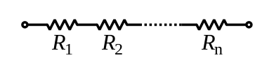
Fig.2 Resistance units in series
Rs=>Resistance in series

Parallel Resistance circuits
If two or more components are connected in parallel, they have the same difference of potential (voltage) across their ends. The potential differences across the components are the same in magnitude, and they also have identical polarities. The same voltage is applied to all circuit components connected in parallel. The total current is the sum of the currents through the individual components, in accordance with Kirchhoff's current law.

Voltage
In a parallel circuit, the voltage is the same for all elements.

Current
The current in each individual resistor is found by Ohm's law. Factoring out the voltage gives
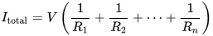.
To find the total resistance of all components, add the reciprocals of the resistances of each component and take the reciprocal of the sum. Total resistance will always be less than the value of the smallest resistance:
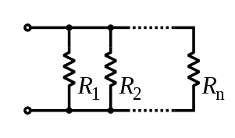
Fig.3 Resistance units in parallel
.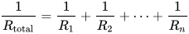
For only two resistances, the unreciprocated expression is reasonably simple:
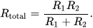
This sometimes goes by the mnemonic product over sum.
For N equal resistances in parallel, the reciprocal sum expression simplifies to:
.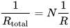
and therefore to:
.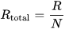
To find the current in a component with resistance , use Ohm's law again:
.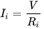
The components divide the current according to their reciprocal resistances, so, in the case of two resistors,
.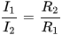

Series and Parallel Resistors: Examples with Detailed Solutions

Example 1
Find the current I passing through and the voltage across each of the resistors in the circuit below. 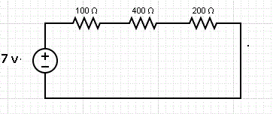
The three resistor in series have a resistance Req given by the sum of the three resistances. Hence
Req = 100 + 400 + 200 = 700 Ω
The current I passing through R1, R3 and R3 is the same and is calculated as follows:
I = 7 v / 700 Ω = 0.01 A
The voltage across each resistance is calculated using Ohm's law as follows:
The voltage across 100Ω: VR1 = 100 × I = 100 × 0.01 = 1 v
The voltage across 400Ω: VR2 = 400 × I = 400 × 0.01 = 4 v
The voltage across 200Ω: VR3 = 200 × I = 200 × 0.01 = 2 v
Example 2
Find current I in the circuit below and the current passing through each of the resistors in the circuit. 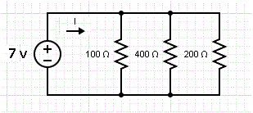Solution to Example 2
The three resistors are in parallel and behave like a resistor with resistance Req given by
1 / Req = 1 / 100 + 1 / 400 + 1 / 200
Multiply all terms by 400 and simplify to obtain
400 / Req = 4 + 1 + 2
Solve for Req to obtain
Req = 400 / 7 Ω
The main current I is given by
I = 7 / Req = 7 / (400 / 7) = 49 / 400 A
We now use Ohm's law to find the current passing through each resistor.
The current through the resistor of 100 Ω: I1 = 7 / 100 A
The current through the resistor of 400 Ω: I2 = 7 / 400 A
The current through the resistor of 200 Ω: I3 = 7 / 200 A
As an exercise; check that the sum of the three currents above is equal to the current I = 49 / 400 A.

Example 3
Find current I in the circuit below. 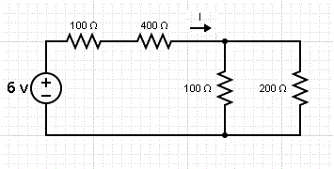Solution to Example 3
The two resistors that are in series are grouped as Req1 in the equivalent circuit below and their resistance is given by the sum
Req1 = 100 + 400 = 500 Ω
The two resistors that are in parallel are grouped as Req2 in the equivalent circuit below and their resistance is given by the equation
1 / Req2 = 1 / 100 + 1 / 200
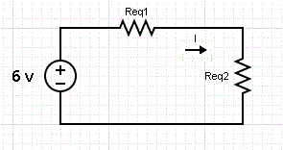
Solve to obtain
Req2 = 200 / 3 Ω
Req1 and Req2 are in series and therefore are equivalent to R given by the sum
R = Req1 + Req2 = 500 + 200 / 3 = 1700 / 3 Ω
We now use Ohm's law to find current I.
I = 6 / R = 6 / (1700 / 3) = 18 / 1700 A
Example 4
What resistance x in parallel with resistances 100 Ω and 200 Ω gives an equivalent resistance of 50 Ω?
Solution to Example 4
Let x be the resistance to be found. The equivalent resistance of the all three resistor in parallel is known. We use the equation that gives the equivalent resistance of resistors in parallel as follows
1 / 50 = 1 / 100 + 1 / 200 + 1 / x
which gives
1 / x = 1 / 50 - 1 / 100 - 1 / 200
Set all fractions on the right to the common denominator 200 and rewrite the above equation as
1 / x = 4 / 200 - 2 / 200 - 1 / 200 = 1 / 200
solve for x to obtain
x = 200 Ω
Example 5
Show that if the resistors with resistances R1, R2 ,..., Rm are in parallel, then the equivalent resistance Req is always smaller than R1, R2, ..., Rm.
Solution to Example 5
The equivalent resistance Req is given by the equation
1 / Req = 1 / R1 + 1 / R2 + ... + 1 / Rm
Since R1, R2, ... Rm are positive quantities, we can write that
1 / Req > 1 / Ri , where Ri is any of the resistances.
Multiply all terms of the inequality above by (Req × Ri) and simplify to obtain
Ri > Req
or
Req < Ri , i = 1, 2, ... m.

Kirchhoff's current law

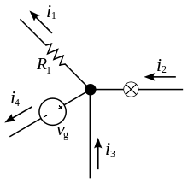
Fig.4 The current entering any junction is equal to the current leaving that junction. i₂ + i₃ = i₁ + i₄
This law is also called Kirchhoff's first law, Kirchhoff's point rule, or Kirchhoff's junction rule (or nodal rule).
This law states that, for any node (junction) in an electrical circuit, the sum of currents flowing into that node is equal to the sum of currents flowing out of that node; or equivalently:
The algebraic sum of currents in a network of conductors meeting at a point is zero.
Recalling that current is a signed (positive or negative) quantity reflecting direction towards or away from a node, this principle can be succinctly stated as:

where n is the total number of branches with currents flowing towards or away from the node.
The law is based on the conservation of charge where the charge (measured in coulombs) is the product of the current (in amperes) and the time (in seconds). If the net charge in a region is constant, the current law will hold on the boundaries of the region. This means that the current law relies on the fact that the net charge in the wires and components is constant.

Kirchhoff's voltage law

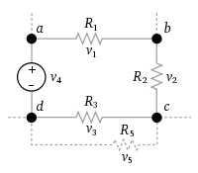
Fig.5 The sum of all the voltages around a loop is equal to zero

The sum of all the voltages around a loop is equal to zero
v₁ + v₂ + v₃ +v₄ = 0
This law is also called Kirchhoff's second law, Kirchhoff's loop (or mesh) rule, and Kirchhoff's second rule.
This law states that
The directed sum of the potential differences (voltages) around any closed loop is zero.
Similarly to Kirchhoff's current law, the voltage law can be stated as:
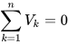
Here, n is the total number of voltages measured.

Example
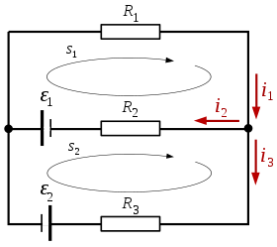
Assume an electric network consisting of two voltage sources and three resistors.
According to the first law:
Applying the second law to the closed circuit s₁, and substituting for voltage using Ohm's law gives:
The second law, again combined with Ohm's law, applied to the closed circuit s₂ gives:
This yields a system of linear equations in :
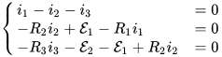
which is equivalent to
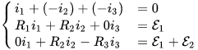

Assuming

the solution is
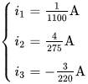
The current has a negative sign which means the assumed direction of was incorrect and is actually flowing in the direction opposite to the red arrow labeled . The current in flows from left to right.

Wheatstone bridge
A Wheatstone bridge is an electrical circuit used to measure an unknown electrical resistance by balancing two legs of a bridge circuit, one leg of which includes the unknown component. The primary benefit of the circuit is its ability to provide extremely accurate measurements (in contrast with something like a simple voltage divider).^{[1]} Its operation is similar to the original potentiometer.

Operation
In the figure, R₁, R_{2,} R₃ resistance values are the fixed and known, R_{X} is to resistance to be measured. The resistance R₂ is adjustable. The resistance R₂ is adjusted until the bridge is "balanced" and no current flows through the galvanometer V_{G}. At this point, the voltage between the two midpoints (B and D) will be zero. Therefore the ratio of the two resistances in the known legs DA and AB equal to the ratio of the two resistances in the unknown leg DC and CB. If the bridge is unbalanced, the direction of the current V_{G} indicates whether is too high or too low.
At the point of balance,
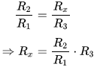
Detecting zero current with a galvanometer can be done to extremely high precision. Therefore, if and are known to high precision, then can be measured to high precision. Very small changes in disrupt the balance and are readily detected.
Alternatively, if and are known, but is not adjustable, the voltage difference across or current flow through the meter can be used to calculate the value of using Kirchhoff's circuit laws. This setup is frequently used in strain gauge and resistance thermometer measurements, as it is usually faster to read a voltage level off a meter than to adjust a resistance to zero the voltage.

Derivation

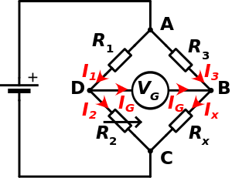
Fig. 6 Wheatstone bridge
Directions of currents arbitrarily assigned

Quick derivation at balance
At the point of balance, both the voltage and the current between the two midpoints (B and D) are zero. Therefore, , , and:
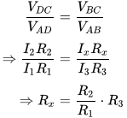

Full derivation using Kirchhoff's circuit laws
First, Kirchhoff's first law is used to find the currents in junctions B and D:
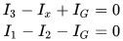
Then, Kirchhoff's second law is used for finding the voltage in the loops ABD and BCD:
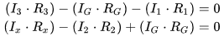
When the bridge is balanced, then I_{G} = 0, so the second set of equations can be rewritten as:
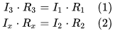
Then, equation (1) is divided by equation (2) and the resulting equation is rearranged, giving:
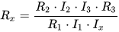
Due to: I₃ = I_{x} and I₁ = I₂ being proportional from Kirchhoff's First Law in the above equation I₃ I₂ over I₁ I_{x} cancel out of the above equation. The desired value of R_{x} is now known to be given as:
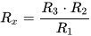
On the other hand, if the resistance of the galvanometer is high enough that I_{G} is negligible, it is possible to compute R_{x} from the three other resistor values and the supply voltage (V_{S}), or the supply voltage from all four resistor values. To do so, one has to work out the voltage from each potential divider and subtract one from the other. The equations for this are:
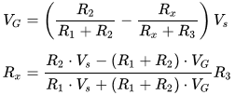
where V_{G} is the voltage of node D relative to node B.
References:
1. “Text book of Physics-I & II” by K.N. Barik, N. Barik and L. K. Das, Kalyani Publisher,2008.
2. sites.google.com
3. en.wikipedia.org
4. www.ukessays.com

Question Banks
1. Define Electricity and writ down its SI unit.
2. Write Ohms Law.
3.Write and explain Kirchhoff’s Laws.
4.Explain application of Kirchhoff’s Laws to Wheatstone Bridge.
5.What resistance x in parallel with resistances 400 Ω and 300 Ω gives an equivalent resistance of 50 Ω?
6. Find the current I passing through and the circuit having voltage source 200v in series with 500ῼ,100 ῼ and 750 ῼ .
7.Find the value of current I₃ and I₂ , where R₁ =100, ῼ ,R₂ =200, ῼ, R₃ =200, ῼ, 100v and
200v.

